**Midterm project proposal**

Luyao Wang

netID: lw337

My midterm project is galaxy screensaver. I am going to make a galaxy using openFrameworks. What I want to do is to make a sense of “flow” with the gradual color change from the color cyan to blue and to purple.

I personally like the smooth transition of colors, and I think making a “galaxy” where colorful stars filled the screen shall be very cool.

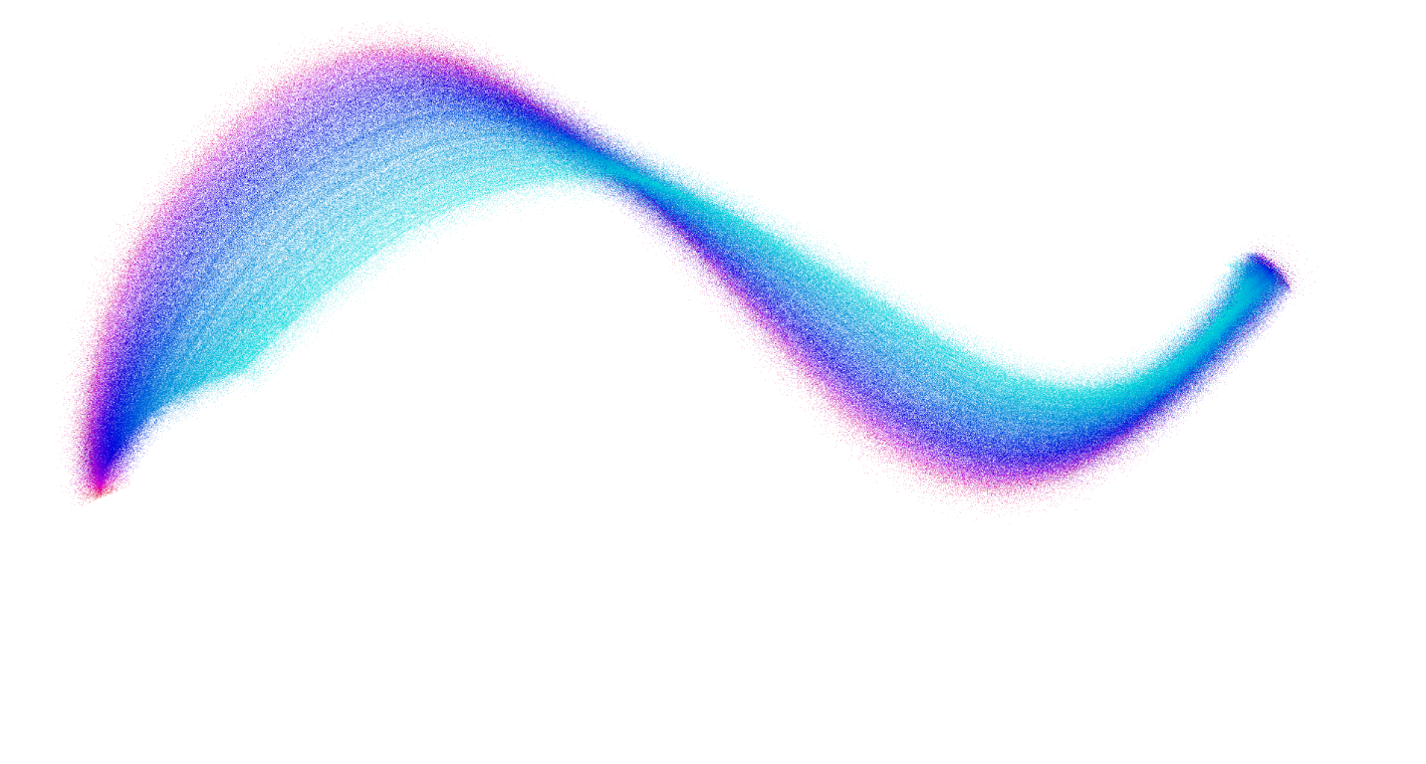

The galaxy can be drawn with the control of the mouse, or automatically, like screensaver. The picture above is drawn with the control of mouse.

Look at the picture above, we can see the gradual transition of color. The density of the stars is also different, when the mouse moves slower, the stars are denser. The galaxy looks like a band of stars. Because the color purple or cyan is always on one side of the band, so the galaxy can somehow be bended with the movement of mouse.

The idea is from the sample code in week 02 class 04, Followers. But the sample code is far from the vision of “galaxy”, so I need to make some adjustments in the following aspects:

First, change ofSetBackgroundAuto to false, which is very obvious.

Second, make smaller the stars, which are small triangles, and make sure there is gap between stars to simulate the “galaxy”.

Third, I want to attain a sense of “flow”, so the velocity of the stars should be slowed.

Fourth, in order to make the galaxy more dynamic, a variable offset should be added. Each triangle should have a constant offset, add to some randomness of the galaxy.

The openFrameworks project have a Star class. A star is represented as a triangle, although it is actually as small as a dot. The Star class has the following instance variables: pos (represents the position of the star), offset (the distance that one star shall be randomly moved to add to dynamics), color, size, angle (used when draw a triangle at a specified direction), lerp (to set interpolation "speed", different color has different speed, so as to make a dynamic “galaxy”). And regularly, the Star class contains a constructor that set an offset for each star, an update and a draw.

In the setup function of the class Star, we create a vector that contains a certain number of stars. Stars of different color have different size and speed. Then, for every frame, we update the vector of stars and draw them.

To attain the sense of “flow”, I want the stars to follow my cursor. The movement is like the zeno one, aka slower and slower towards a destination. As a result, when the mouse moves fast, the distance between the cursor and the current position is longer, so the stars moves faster, and the galaxy is less dense. Similarly, when the mouse moves slow, the speed of the stars is also slow, and the galaxy is denser. The speed of different colors is different cyan is slower, and red is faster, where some asymmetry is made to make the galaxy more dynamic.

In addition, I want to make a screensaver, which is automatic and does not need the mouse to control it. So, the vector target (specifies where the stars shall go) should not be the position of cursor. A solution is to use some mathematical expressions to get an x and a y for the movement of the movement of the stars. Maybe it can be implemented with Lissajous-Figure. However, in this case, the curve is in a way repetitious, so the expression of Lissajous-Figure might change over time to create randomness.

Another important thing is that you can create your own image with the control of mouse. The shape of the galaxy is designed by yourself!

Some bigger stars could be added, such as a pentagram, twinkling in the galaxy. These pentagrams represent stars that are closer to the viewer, while the galaxy composed of bands of different colors is a background.

Some interactions might be added in ofApp such as mode control, automatic or control by mouse. Other interactive functions could also be added, such as clearing the screen or the speed of the stars.

In conclusion, my midterm project deals with visualization. The design is to make a galaxy composed of colorful bands. In addition, some pentagrams representing bigger stars shall be added,